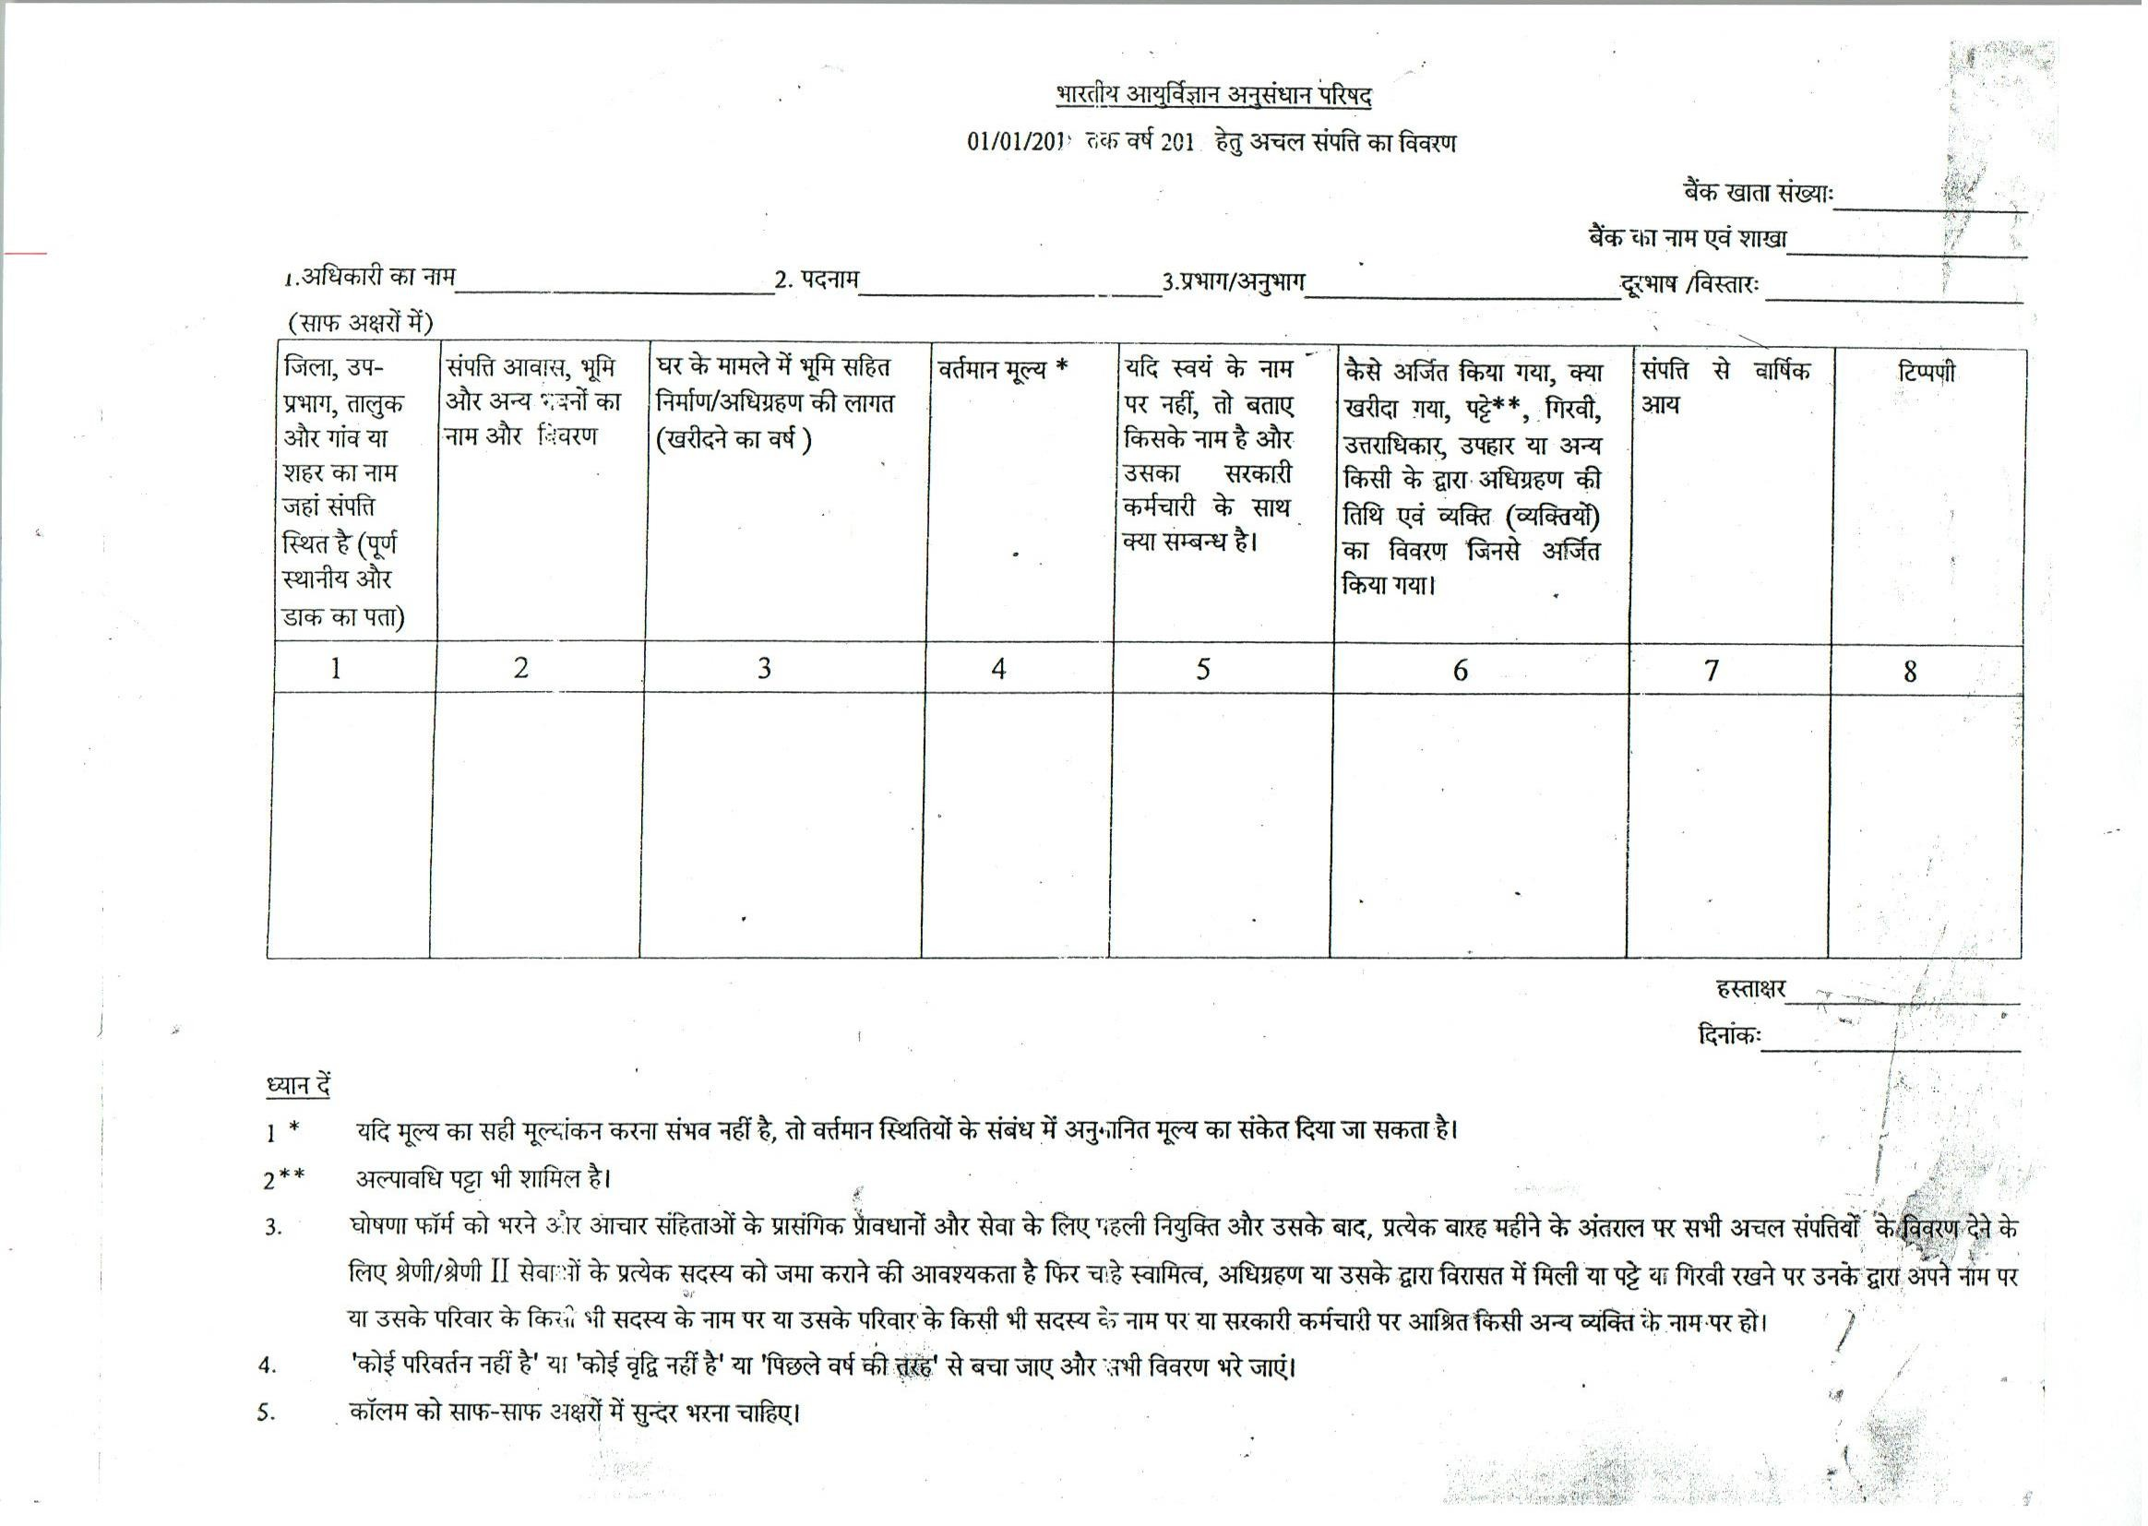

ICMR-NATIONAL INSTITUTE FOR RESEARCH IN ENVIRONMENTAL HEALTH, BHOPAL

STATEMENT OF IMMOVABLE PROPERTY FOR THE YEAR 2018 AS ON 1.1.2019
Bank Account No. …………………………………
Bank’ name & Branch……………………………………………………..

1. Name of Officer (in Block letters) ……………………………..…………. 2. Designation………………...…….. 3. Division/Section_ ……………………………_ Cont. No. …..…………………….

S. | Name of District, Sub-Divion, | Name of & Details | Cost of construction/ | Present Value* | If not in own | How acquired | Annual | Remarks
No. | Taluk & Village or City in which | of Property, | Acquirement (and year |  | name, state in | whether by | Income
 | property is situated (full | Housing, Lands | when purchased) |  | whose name | purchase, | from
 | location and postal address). | and other Buildings | including of land in case of house |  | held and his/her | lease**, mortgage, | property
 |  |  |  |  | relationship to | lease,
 |  |  |  |  | the Govt. | inheritance, gift
 |  |  |  |  | Servant | or otherwise
 |  |  |  |  |  | with date of
 |  |  |  |  |  | acquisition and
 |  |  |  |  |  | name with
 |  |  |  |  |  | details of
 |  |  |  |  |  | person(s) from
 |  |  |  |  |  | whom acquired
(1) | (2) | (3) | (4) | (5) | (6) | (7) | (8) | (9)
1
2 |  |  |  |  |  |  | Nil

Note –
SIGNATURE……………………………….……………………………………
Date………………………………………………………………..…..

- * In case where it is not possible to assess the value accurately, the approximate value in relation to present conditions may be indicated.
- ** Include short terms lease also.
- The declaration form is required to be filled in and submitted by every member of Class I and Class II services under relevant provisions of Conduct Rules on the first appointment to the service and thereafter at the interval of every twelve months, giving particulars of all immovable property owned, acquired or inherited by him or held by him on lease or mortgage, either in his own name or in the name of any members of his family or in the name of any other person dependent on Government servant.
- The wording ‘no change’ or ‘no addition’ or ‘as in the previous year’ should be avoided and all details filed.
- The columns should be filled up neatly in capital letters.

SIGNATURE……………………………….……………………………………

